**UNIVERSITY OF INFORMATION TECHNOLOGY**

**HO CHI MINH CITY NATIONAL UNIVERSITY**

**Cloud Computing**

**Group 5**



**Big Assignment Report**

**Lecture:** Phan Xuân Thiện

**Members:** Nguyễn Thành Trung 19522431

Nguyễn Thanh 19522233

Nguyễn Đức Toàn 19522362

Đỗ Hoàng Phúc 19522027

Trần Lương Tiến Sĩ 19522128

Thành phố Hồ Chí Minh, ngày 25 tháng 11 năm 2022

**1. Install mpi packages on master and node 1 and node 2 machines.**

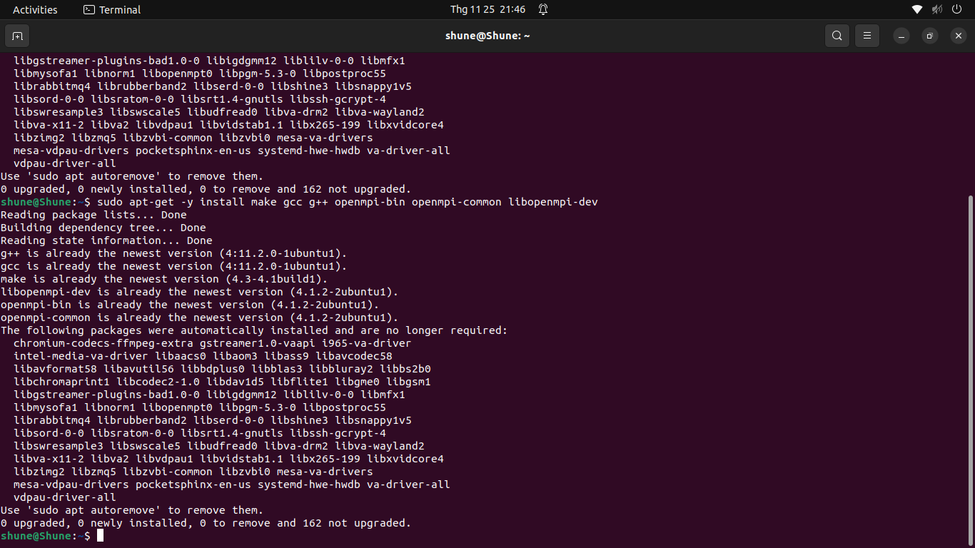

Figure 1: Install mpi packages on master.

Figure 2: Install mpi packages on node1.

Figure 3: Install mpi packages on node1.

Figure : Install mpi packages on master.

Figure : Install mpi packages on node1.

Figure : Install mpi packages on node1.

**2. Create public/secret key in master to share with node 1 and node 2 machines**

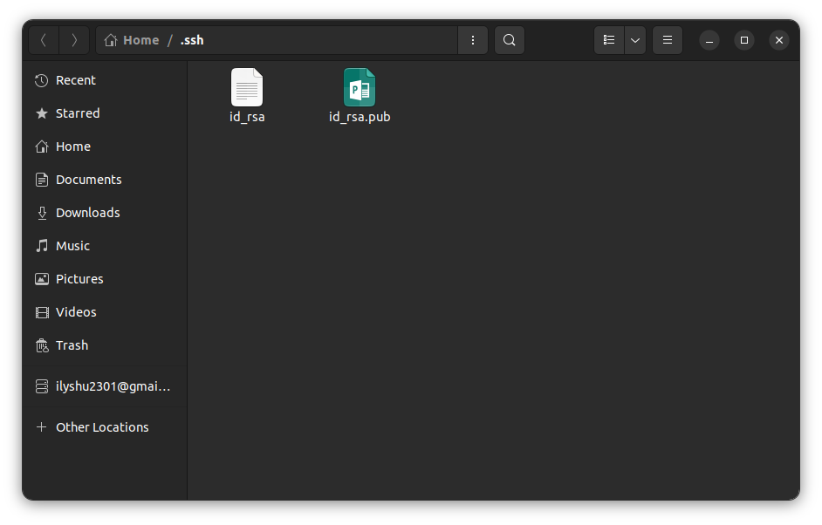

Figure : Public/secret key generated on master.

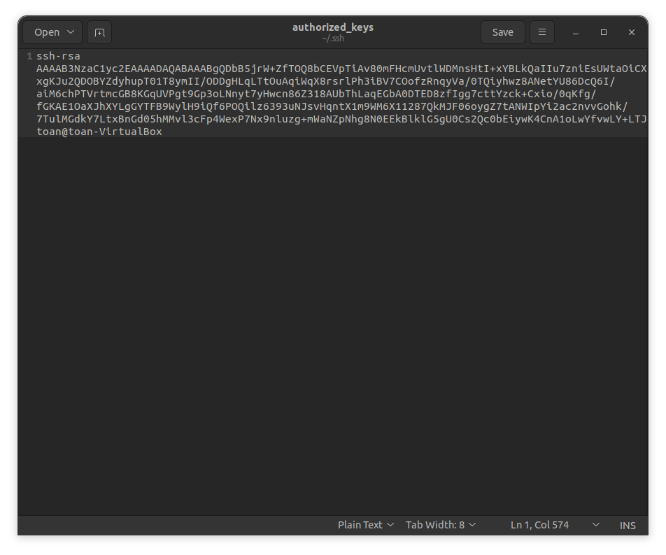

Figure : Public/secret key in master to share with node 1 and node 2 machines.

**3. Connect machines together using hostname mpi**

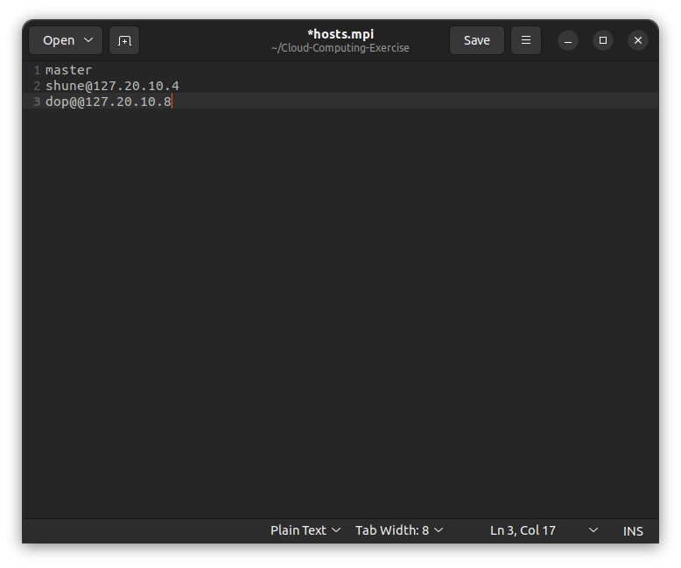

Figure : Create hosts.mpi file and fill in ip node 1 and node 2 machine.

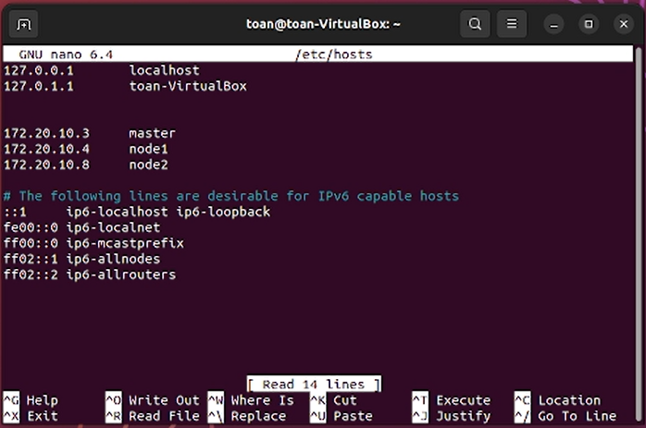

Figure : mpi connection information 3 machines: master, node1 and node2.

**4. Compile the pi.c file and run mpi it on 3 machines: master, node1 and node2**

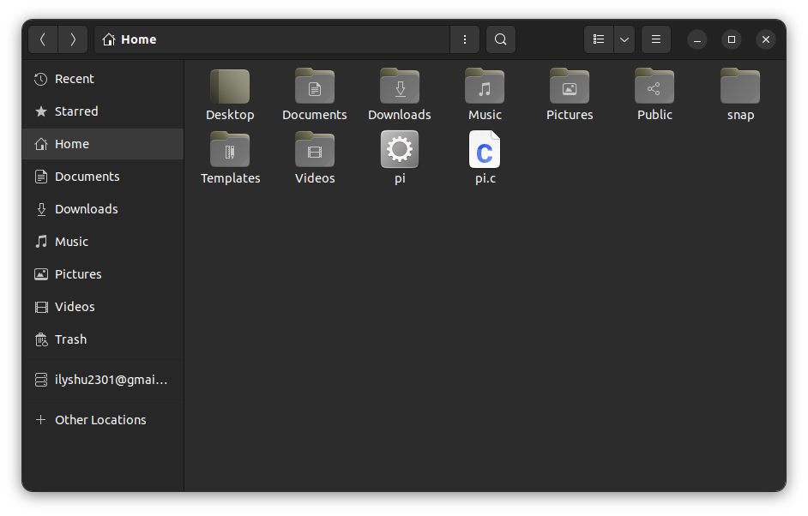

Figure : Complite file pi.c then send to node1 and node2 and run mpirun

Figure : The result after calculating pi